
Christopher S. Gordos, DPT
Eric A. Parrish, MPT
p)610-944-8140 f)610-944-8190
imgpt@imgpc.com
www.imgpt.com

RESTORING FUNCTION ONE PATIENT AT A TIME
805 N Richmond Street, #103, Fleetwood, PA

Balance Exercises to Improve Golf Performance and Prevent Injury During Golfing

Overview of the Golf swing:
- The golf swing requires significant amounts of rotational movement to provide torque and enough force to increase distance of ball travel
- The golf swing requires significant transfer of center of gravity from the rearfoot at the top of the backswing to the front foot through the downward swing and follow through
- These rotational and weight shifting components require adequate range of motion and balance at multiple joints throughout the body, including the neck, thoracic spine (mid-back), lumbar spine (low back), hips, knees, and ankles
- Balance allows for optimal stability and range of motion throughout the golf swing to improve stability and reduce the risk of injury
- Balance has been noted to be a key factor in improving golf performance, including positive correlations with ball speed and clubhead speed
- When performing balance exercises, for safety do with a chair or cane until ready to perform without hand/arm support.
- If you have pain with any of these exercises, stop immediately and call your therapist. Never push through pain.
- 3rd page is some ideas on how to decrease the stress on your body and allow you to play golf without the pain.
- Combine the balance program with the return to golf exercises and progression program for optimal benefit. Can be found on same IMGPT.COM website.

Exercises to improve balance and golf performance
Tandem stance balance: perform for 3 sets of 15-30 seconds to improve static balance | 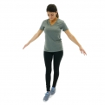
Single leg airplanes: perform for 3 sets of 5-10 repetitions per side to improve single leg rotational balance, hip range of motion | 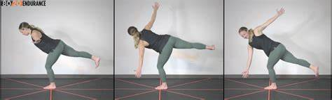
Windmills: Perform 3 sets of 5 to 10 repetitions each side to improve dynamic stability and hip range of motion | 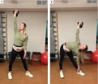
Cable or banded chops/lifts: Perform 3 sets of 10 repetitions per side to strengthen rotational muscles and improve dynamic core stability | 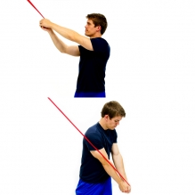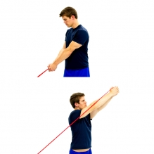
Stork turns: Perform 3 sets of 10 repetitions to improve hip range of motion and rotational stability | 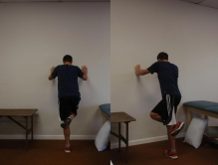

Body positioning adjustments to improve balance and reduce risk of injury:
External rotation of lead foot up to 30 degrees to reduce rotational force on lead knee | 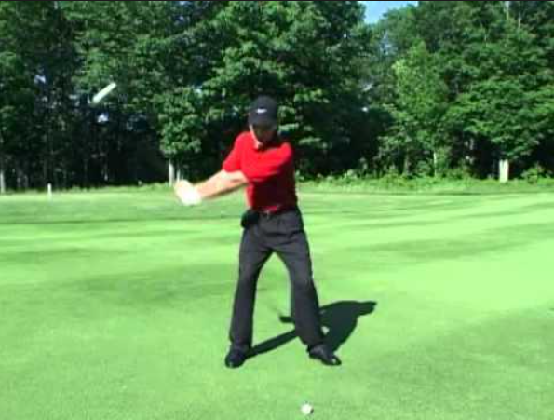
Wider stance to decrease amount of lateral weight shift and offload lead knee | 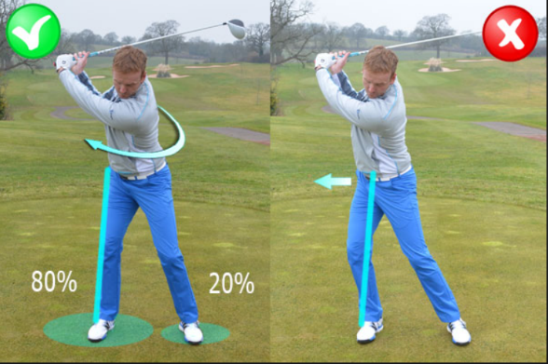
Decrease range of motion in backswing and follow through to decrease amount of torque and load on lower back | 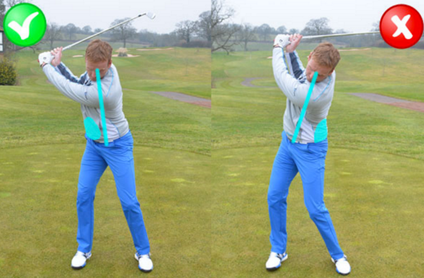
Decrease lateral shoulder sway and range of motion of backswing to decrease forces on shoulder joint to avoid rotator cuff irritation and shoulder instability | 