Baseball Arm Care Plan Using Resistance Bands, Weighted Balls, and Plyometrics
Introduction
The purpose of this program is to educate and provide a program that uses these popular tools for arm care to help prevent arm injuries, improve muscle strength, improve mechanics, and improve overall performance. Each tool has a specific use and benefit and if used effectively and correctly can produce these benefits. However, these tools must be used with caution because improper use and incorrect technique can lead to injury.
Why is this important for preventing injuries?
The majority of baseball injuries are noncontact injuries to the dominant throwing arm. According to the research, 5% of youth players suffer a serious elbow or shoulder injury within 10 years of playing that can cause surgery or in some cases retirement from playing. The biggest risk factor for this is the amount of pitching and throwing including the number of pitches per game, innings per season, months per year playing, and multiple teams to name a few. Other factors can include pitching while your arm is still fatigued, improper biomechanics of the throw, throwing breaking pitches at an increasingly young age, and maximum effort with every throw.
Common Injuries that can occur (but not limited to):
- Ulnar Collateral Ligament Tears (Tommy John)
- SLAP tears (Shoulder/Labrum)
- Rotator Cuff Tendinopathy and Tears (Shoulder)
- Impingement (Shoulder)
- Flexor Pronator Strains (Forearm)
- Olecranon Stress Fractures (Elbow)
- Growth Plate Injuries (Elbow/Wrist)
If any problems or pains arise in your arm or shoulder while throwing or performing this program, consult your physical therapist or physician. If you have any questions on where to get this equipment, how to correctly perform, or any other problems that arise, contact your physical therapist.
IMPORTANT NOTE: Pitchers, no more than 9 months throwing a year and must get at least 3 months consecutive of rest from throwing to allow for proper recovery time.

Resistance Bands
Benefits
- Improve rotator cuff and shoulder stabilizer strength
- Improve muscle control during the deceleration phase of throwing
Improve shoulder control
- Improve Dynamic Stability
Exercises
- Perform 3 sets of 10-15 reps
- Perform 3 to 5 times a week
- Have Resistance Bands Attached to a secure point
- External Rotation at 0 and 90 degrees Abduction
Stand holding the band in your involved hand. For 0 degrees abduction, your arm should be bent in the shape of an L and close to your body. Slowly move your arm outward away from your body using your shoulder muscles to perform the movement. For 90 degrees abduction the starting position is facing the anchor point with your arm in a L shape and parallel to the ground. See pictures 1-3 at the bottom of this section.
- Band Pull Apart
While holding an elastic band with your elbows straight in front of your body, pull your arms apart and towards the side. Squeeze your shoulders blades together at the end. See picture 4 at the bottom of this section.
- Dynamic I, Y patterns
Start standing facing anchor point with band in both hands. For Y pattern raise arms up and out in diagonal pattern to form a Y. Keep the thumbs pointed upwards throughout the motion. For the I pattern start with the bands at eye level and raise arms straight up until they are parallel or slightly above shoulder level. Slowly return to the starting position. See pictures 5 and 6 at the bottom of this section.
- Scapula Protraction Punches
Hold one end of band in each hand at shoulder height with elbows slightly bent. Press forward like a punch. Once your elbows are fully extended protract your scapula by reaching as far as you can without shrugging. See Picture 6 at the bottom of this section.
- Internal Rotation at 0 degrees Abduction
Hold the end of the elastic band with your hand and bend your elbow to 90 degrees. Position your shoulder so that it is rotated out to the side as shown. Next, pull the band towards your stomach as you rotate your shoulder inward. See picture 7 at the bottom of this section.
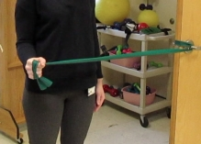(1)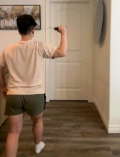(2)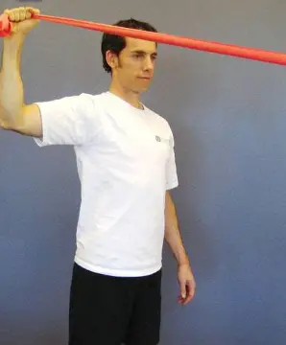(3)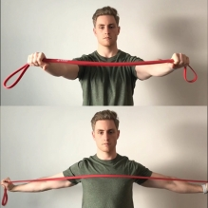(4)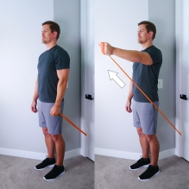(5)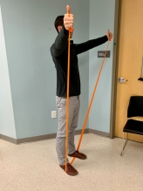(6)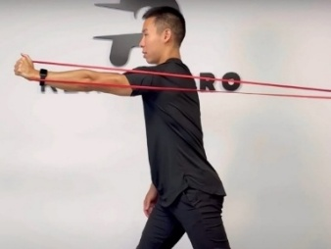(7)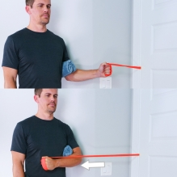(8)

Plyometrics
Benefits
- Train Explosive Power and Mind/Muscle Control
- Improve Force Transfer during throwing
- Improve Reactive Stability
- Enhance Core Control
- Promote Elastic Energy Utilization
Exercises
- Perform 3 to 5 times a week

- Medicine Ball Scoop Toss
Set up facing a wall in an athletic base position while holding a medicine ball at waist level with a soft bend in your arms and knees. Rotate to one side and load back into the hip. Rotate explosively with the hips and throw the medicine ball into the wall directly in front of you. Perform 3 sets of 10 to 15 reps on both sides. See picture 1 at the bottom of this section.
- Medicine Ball Wall Throw
Start in a standing position with a tight core and flat back. Holding a medicine ball with both hands, face a wall and distance yourself about 5 feet away. Squat down with the ball close to your chest and a tight core. Explode up and throw the ball up the wall. Perform 3 sets of 10 to 15 reps. See Picture 2 at the bottom of this section.
- Plyo Pushups
Get into a standard push up position. Lower your chest to the ground like a normal push up. Push up with enough force to have your hands leave the ground. Land softly on your palms. Perform 3 sets of 10 to15 reps. See picture 3 at the bottom of this section.
- Burpees
Begin in a standing position. Drop into a squat driving your knees slightly past your toes. Keep your feet flat on the floor and place your hands on the floor in front of your feet. Kick your legs back into a push up position with your back flat. Lower chest to the ground while keeping your back flat and core tight. Push back up and bring feet close to your hands. Rise back up to complete the rep. Perform 3 sets of 10 to 15 reps. See Picture 4 at the bottom of this section.
(1)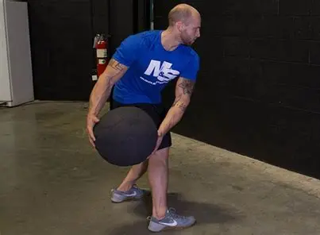(2)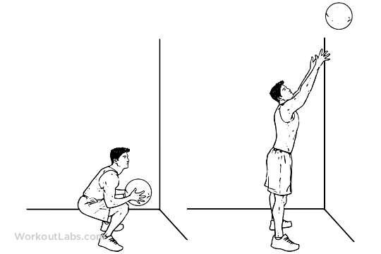(3)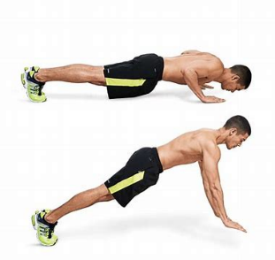(4)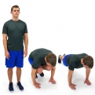

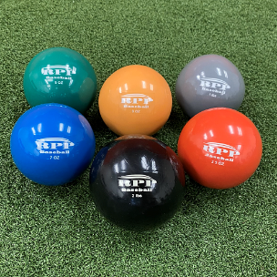
Weighted Balls (MOST LIKELY TO LEAD TO ARM INJURIES)
Benefits
- Improve Velocity safely by reinforcing proper mechanics at sub-maximum effort
- Improve Arm Speed and Deceleration Capacity
- Expose Arm to Progressive loading
- Train for Strength
- Train for Arm Speed
WEIGHTED BALL USE SHOULD BE SUPERVISED AND IS NOT APPROPRIATE FOR YOUTH PLAYERS UNTIL REACHING MUSCULOSKELETAL MATURITY. IF IN SEASON, PERFORM 1 OR 2 TIMES PER WEEK AT A LOW VOLUME. IF IN THE OFF SEASON, PERFORM 2 OR 3 TIMES PER WEEK.
Exercises: ALL EXERCISES ARE DONE AT 60-70% MAXIMUM EFFORT.
- Reverse throws
Start in a half kneeling position. Hold the ball in your hand with your arm straight to start. To do the exercise, you throw the ball back into the wall behind you in a reverse pattern of how you would normally throw. Perform 2 sets of 10 reps with a 1- or 2-pound ball. See picture 1 at the bottom of this section. https://www.youtube.com/watch?v=f_87DD6pnjA
- Marshalls
Start with feet squared to target and the torso slightly counter-rotated. Use normal arm action but make sure the arm is driving back in a supinated position. As torso rotation begins, glove-side should remain folded and throw against a wall. Perform at 60-70% effort. Perform 2 sets of 10 reps with 1-to-2-pound weighted balls. See picture 2 at the bottom of this section. https://youtu.be/0bzY18_d170
- Step Behind Throws
Start with feet hip-width apart in an athletic stance. Drive and rotate hips towards target while keeping front shoulder closed. Perform 2 sets of 10 reps, with a weighted ball 9 oz or less. See picture 3 at the bottom of this section. https://youtu.be/7e71jCjT6wQ
- Step back Throws
Start with feet shoulder width apart in the balance position. Step back 1 to 2 feet (at the most) while counter-rotating to load the back hip. Drive forward and throw. Perform 2 sets of 10 reps with a weighted ball 9 ounces or less. See picture 4 at the bottom of this section. https://youtu.be/GNo4EzdGFrA
(1)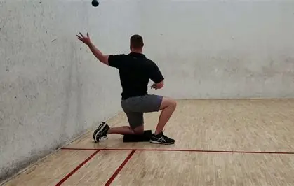(2)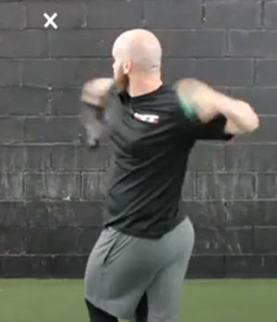
(3)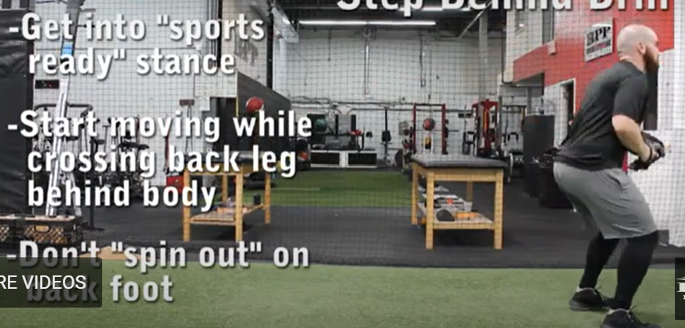(4)