
Christopher S. Gordos, DPT
Eric A. Parrish, MPT
p)610-944-8140 f)610-944-8190
imgpt@imgpc.com
www.imgpt.com

RESTORING FUNCTION ONE PATIENT AT A TIME
805 N Richmond Street, #103, Fleetwood, PA

Shaking Things Up: A New Tool for Shoulder Recovery
If you've had a shoulder injury or surgery, you may have noticed your therapist introduce a strange-looking flexible rod that wobbles when you hold it. That's called a BodyBlade (or a similar "oscillating" device), and there's a good reason we use it.
Why we use it: Most shoulder exercises ask your muscles to push or pull against something steady, like a resistance band or a weight. This blade does something different — it vibrates rapidly in your hand, and your shoulder has to react automatically to keep your arm steady. That "automatic reacting" is actually a skill your shoulder needs just as much as raw strength, especially after an injury. It helps retrain the small stabilizing muscles around your shoulder blade and rotator cuff to fire quickly and work together, the way they're supposed to during everyday activities.
What the research tells us: Several studies have measured muscle activity during these exercises and found that this kind of training really does turn on the right muscles — particularly the ones that stabilize your shoulder blade and rotate your arm.
What you'll feel: A gentle shaking or vibration sensation, and your muscles working harder than you'd expect from such a light tool. That's normal. Sharp or increasing pain is not — if that happens, let your therapist know right away.
How it fits into your care: This isn't a stand-alone treatment — it's one tool among several (manual therapy, stretching, functional exercises) that your therapist will layer in and progress over time, starting gentle and gradually adding more challenge as you heal.
Where to start and when to progress: Beginners should start with a smaller blade because it is easier to control and less intense. Start with 10-30 seconds as able and repeat for 3 sets. As the exercise gets easier, increase the time as you are able without pain until you are able to do 3 sets of 60 seconds without shrugging your shoulder to make it easier. Once you can do this, progress to a longer blade and repeat the progression.

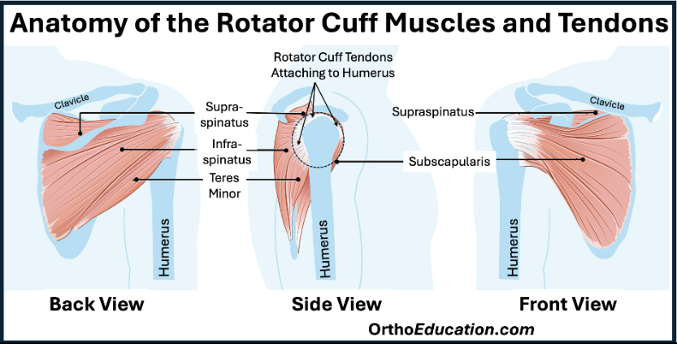

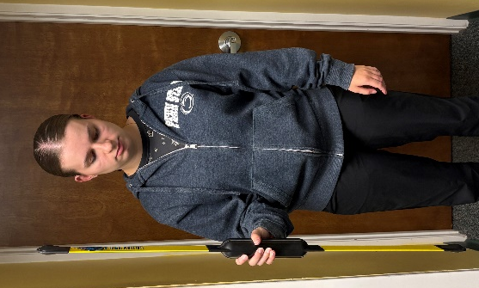
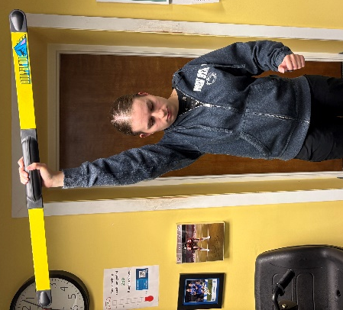
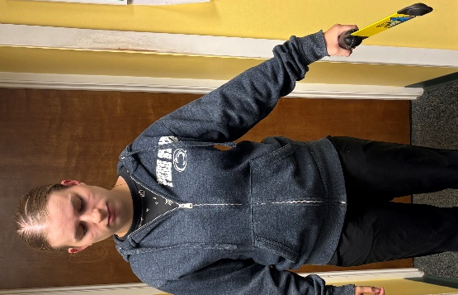
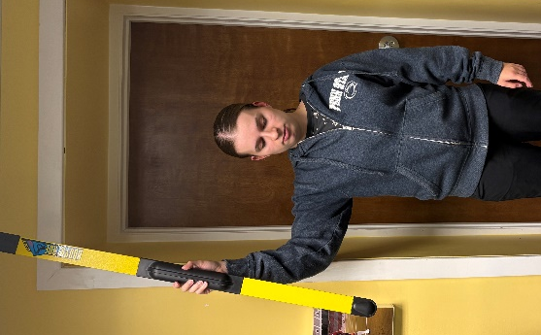
Position 4. The overhead position targets the lower trapezius which is responsible for scapular positioning. With the elbow straight raise the shoulder straight up with the palm facing forward. Oscillate forward to backward.
Position 2. The 90-90 position is a progression to the 90-0 position and targets the same muscles. Bend elbow at 90 degrees, lift shoulder to 90 degrees, palm facing forward. Oscillate front and back.
Position 3. This position targets the supraspinatus which initiates lifting the arm to the side. The arm should be lifted to the side, elbow straight, and palm facing in. Oscillate toward the body and away from the body.
Position 1. The 90-0 position targets the Infraspinatus and teres minor in a less intense way than the 90-90 position. These muscles are responsible for reaching behind the body. Place the elbow at the side bent at 90 degrees, with palm facing in. Oscillate in and out.

